**RIP (Routing Information Protocol):**

■ It is a distance vector routing protocol.

■ It uses hop count as its only metric for path selection.

■ Advertised routes with hop counts greater than 15 are unreachable.

■ Messages are broadcast every 30 seconds.

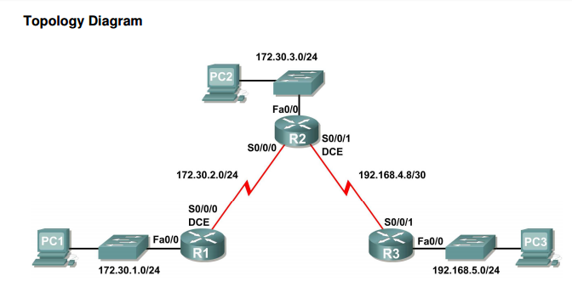

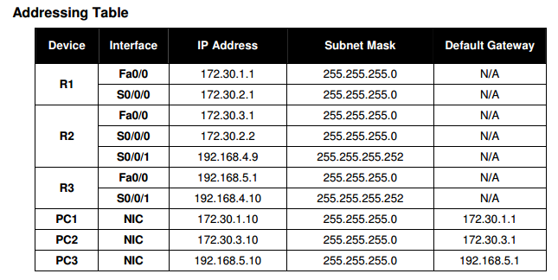

**Task 1: Check Serial line Data Terminal Equipment (DTE) and Data Communications Equipment (DCE):**

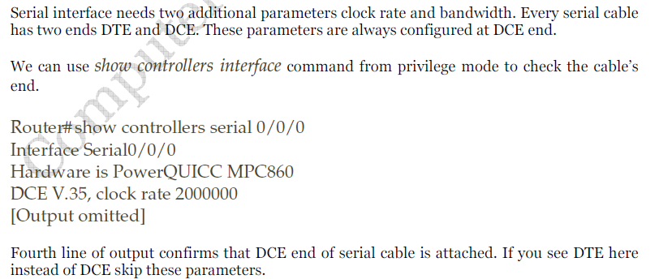

**Task 2: Set Serial line clock rate and bandwidth:**

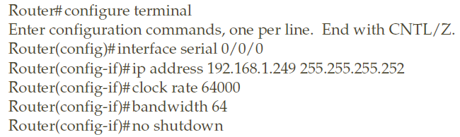

**Task 3: Remove static ip route:**

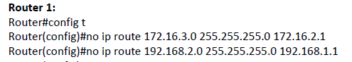

**Task 4: Configure RIP Protocol**

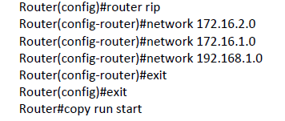

**Task 5: Verify RIP Routing**

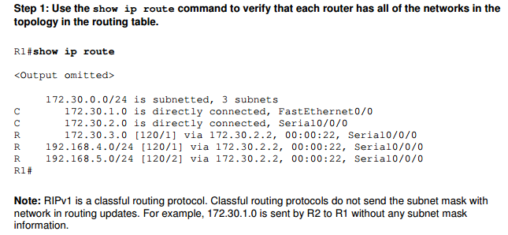

**Task 6: Verify that all necessary interfaces are active.**

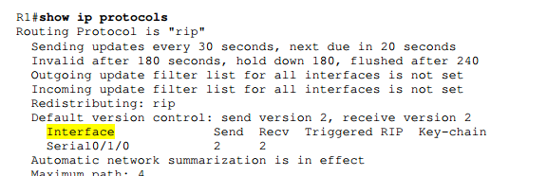

**R1#show ip rip database**

**Task 7: View the RIP messages being sent and received:**

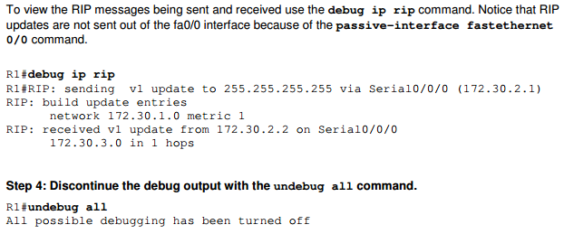

**Task 8: tracert**